EMS MARKS
MARK UPDATE FOR UP TO 10 AUG

2026-12084-114 Economics / Ekonomie - 114 - THIS COURSE ENDED AND WILL NLOT CONTINUE IN SEMSTER 2
2026-12084-144 Economics / Ekonomie - 144- NO MARKS TO GIVE YET
2026-14223-188 Statistics And Data Science / Statistiek en Datawetenskap - 188:
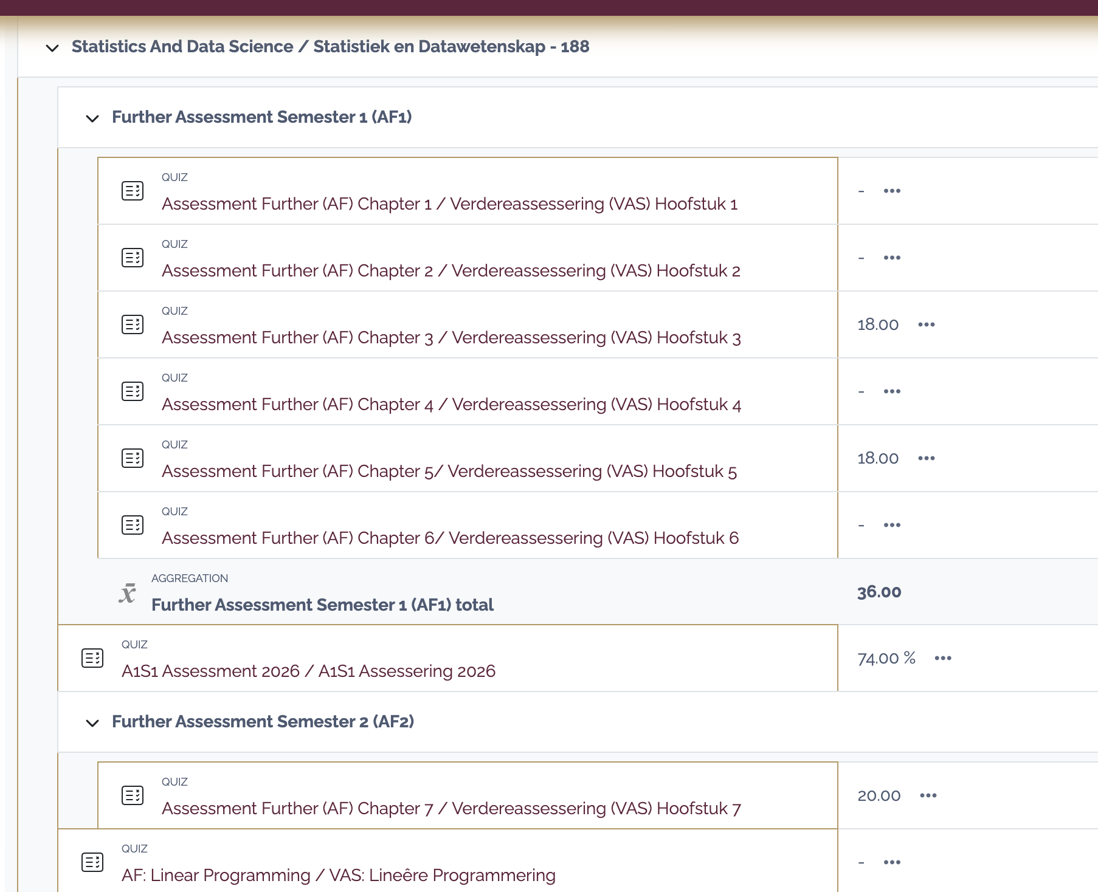
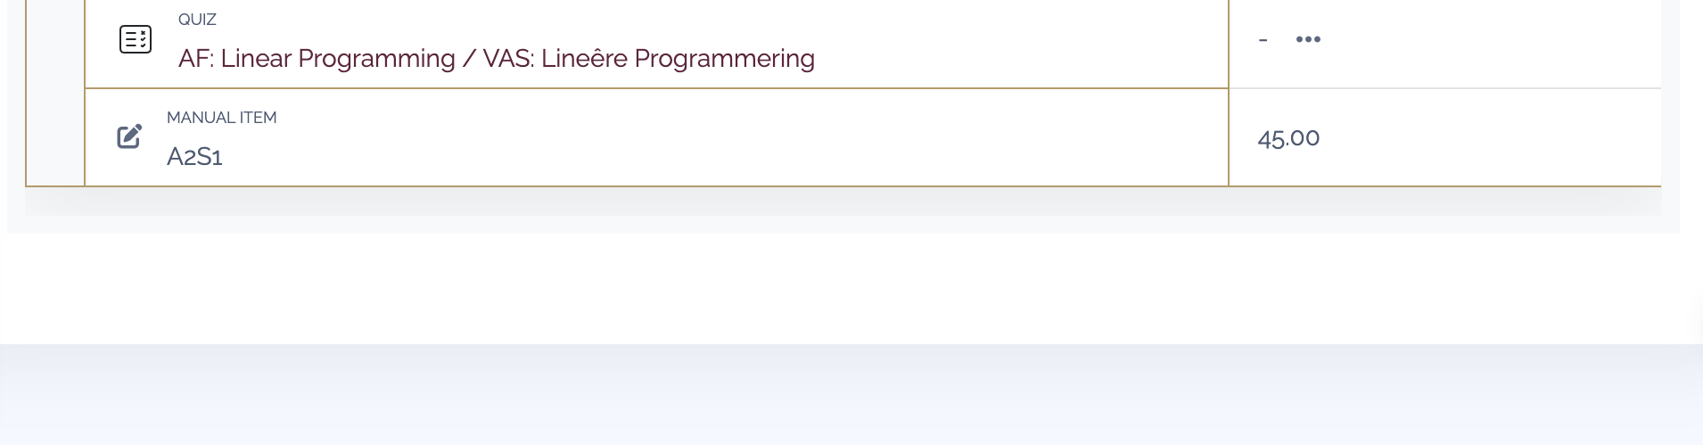
2026-14523-112 Digital- And Leadership Acumen / Digitale- en Leierskapsvernuf - 112 - THIS MODULE HAS ENDED
2026-14523-122 Digital- And Leadership Acumen / Digitale- en Leierskapsvernuf - 122 - THIS MODULE HAS ENDED
2026-14523-142 Digital- And Leadership Acumen / Digitale- en Leierskapsvernuf - 142
NONE YET
2026-14523-152 Digital- And Leadership Acumen / Digitale- en Leierskapsvernuf - 152 - NONE YET
2026-26883-178 Financial Accounting / Finansiële rekeningkunde - 178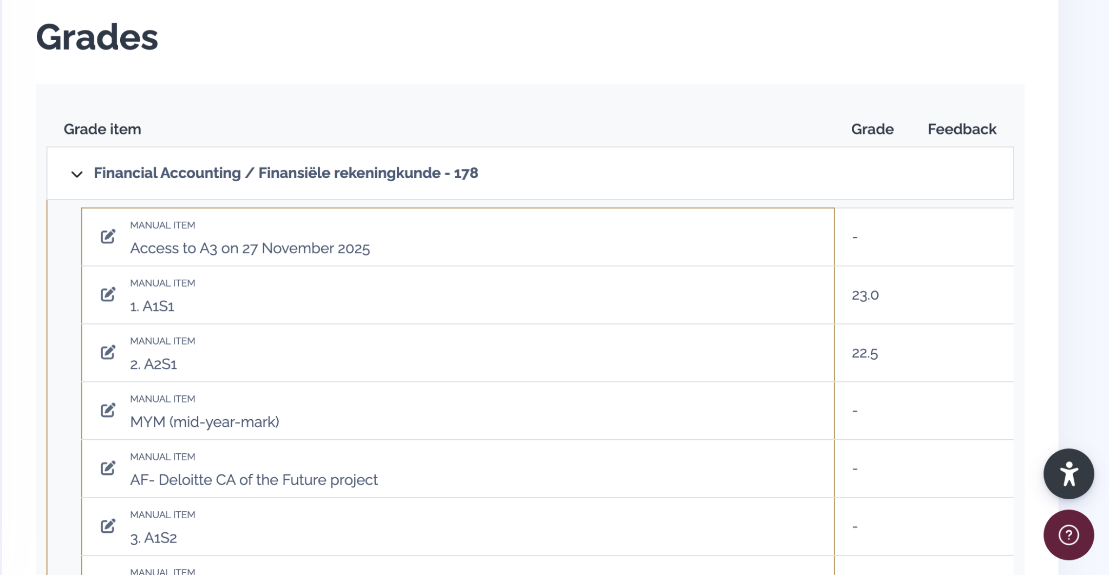  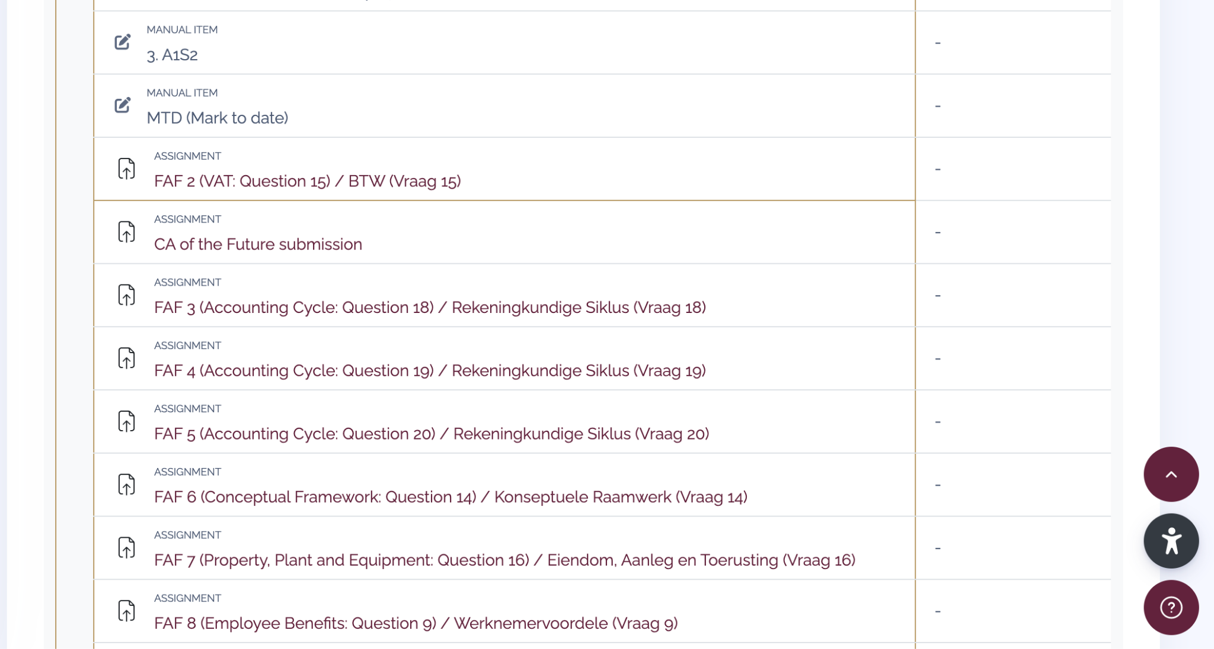 |  | 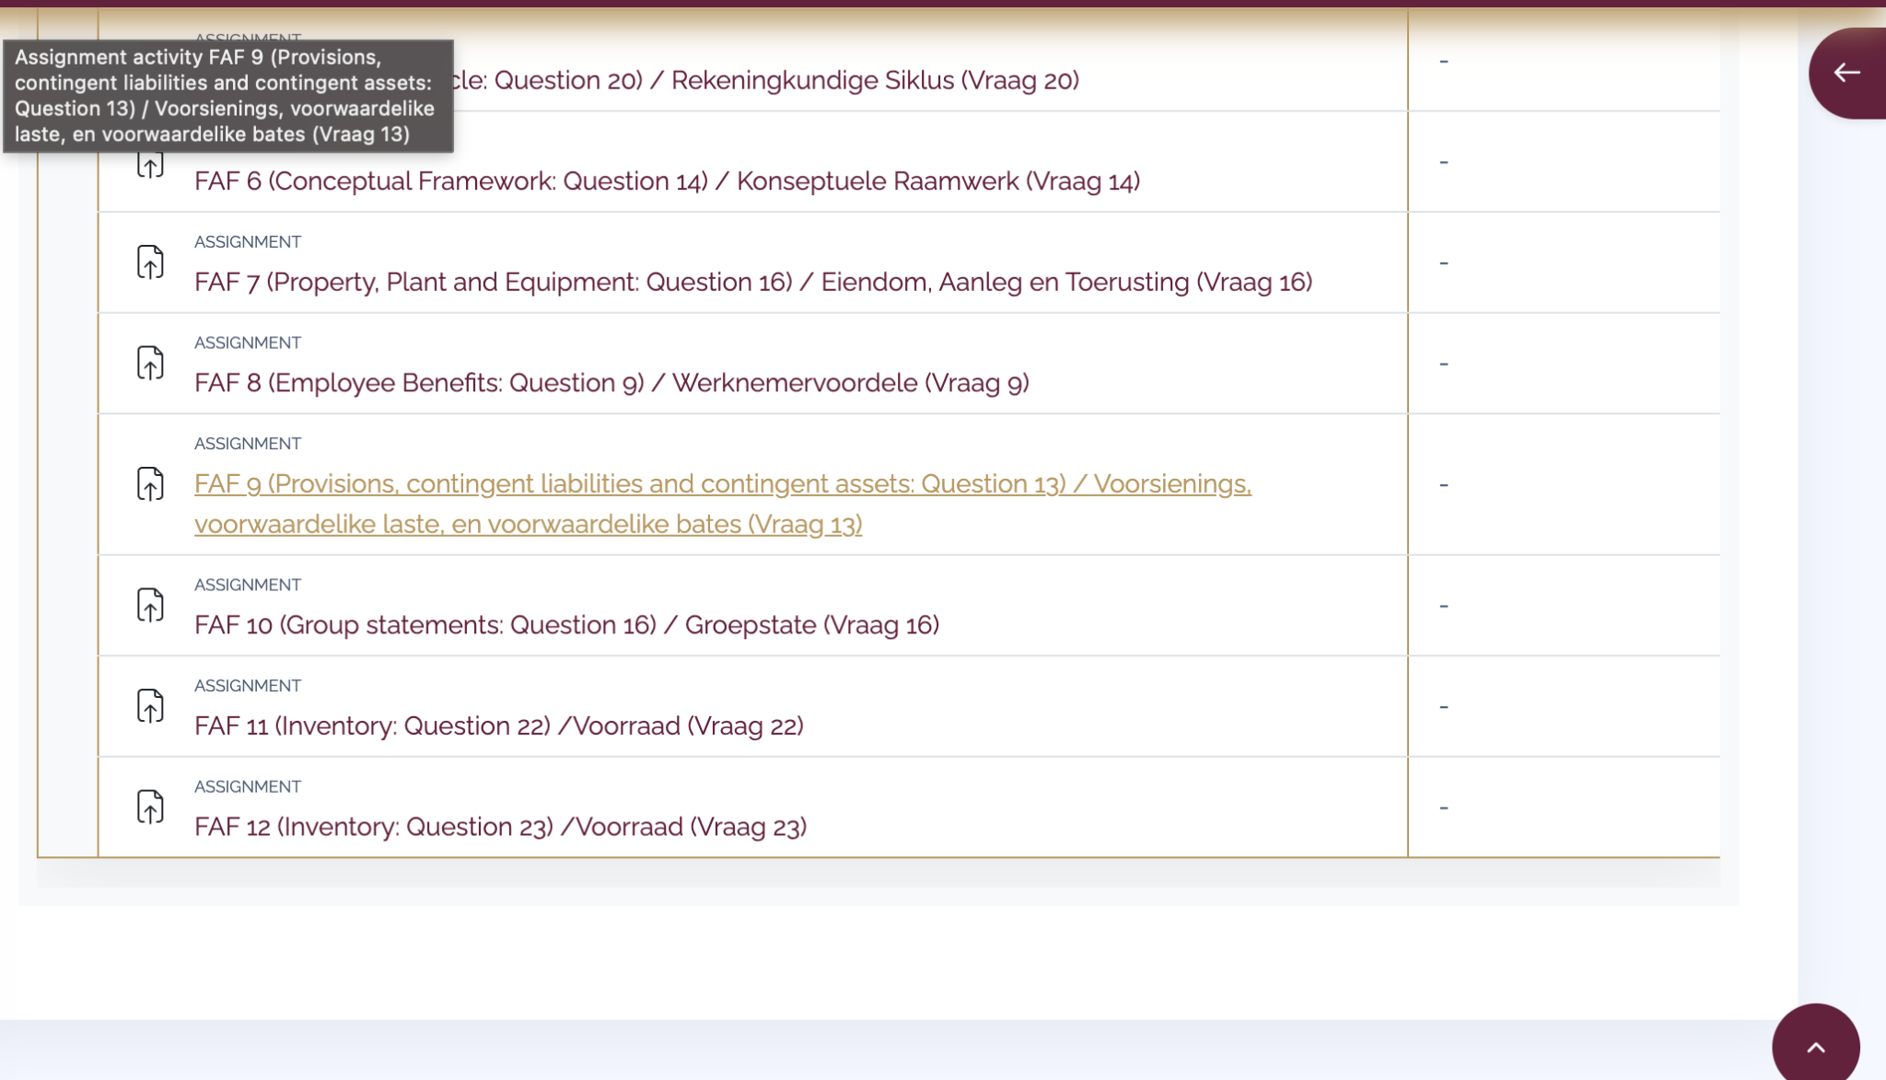
2026-38784-142 Theory Of Interest / Renterekening -
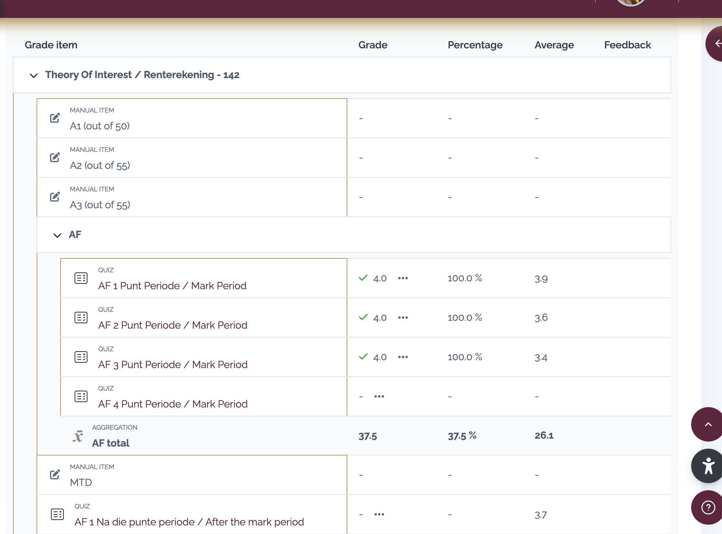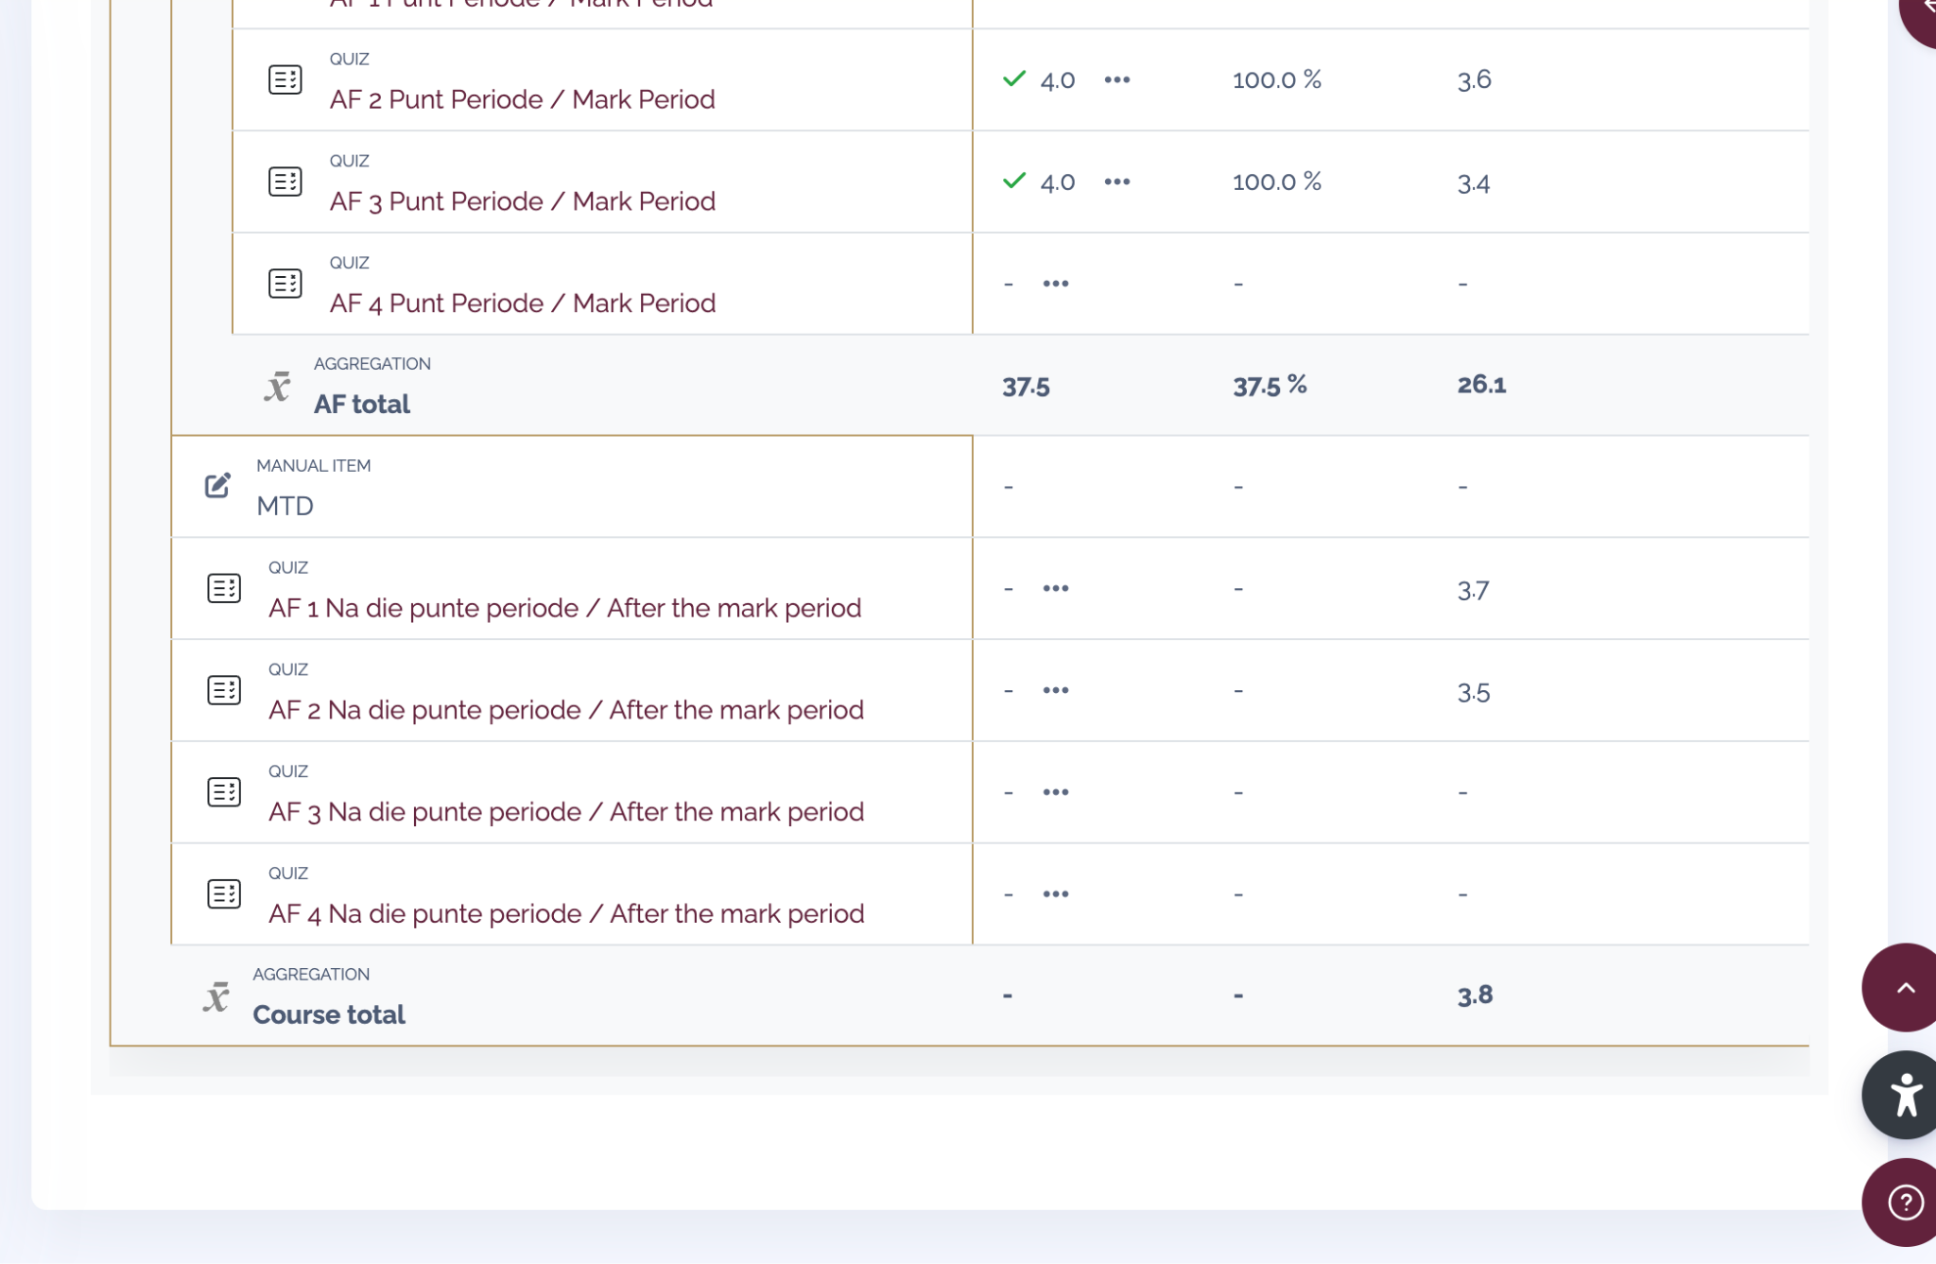

LAW MARKS

2026-14334-178 Foundations Of Law / Grondslae van die Reg - 178  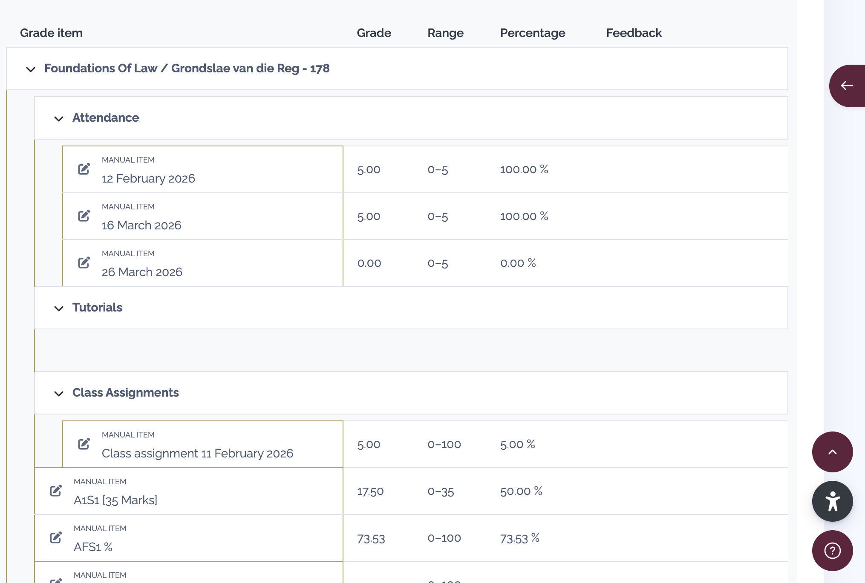 | 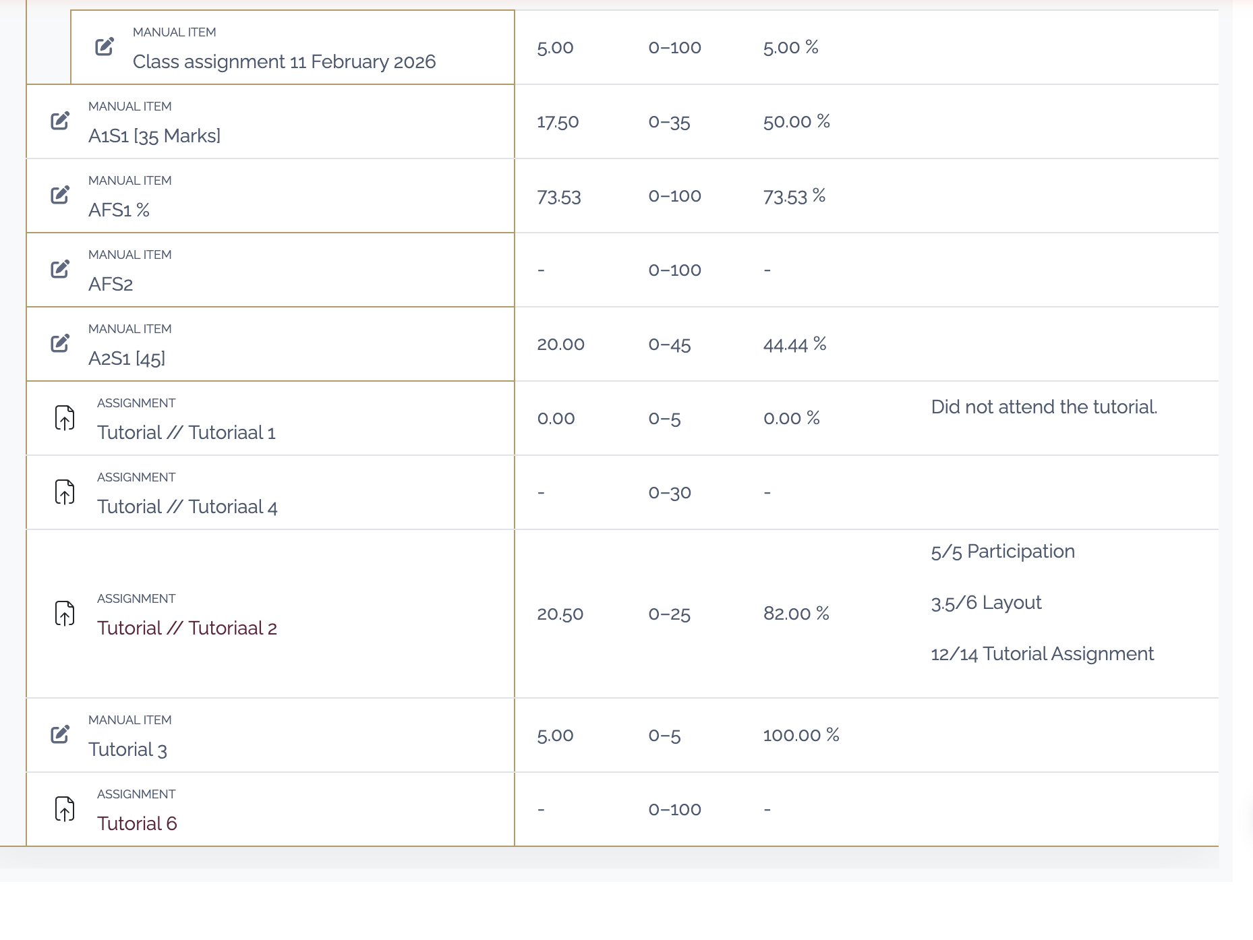
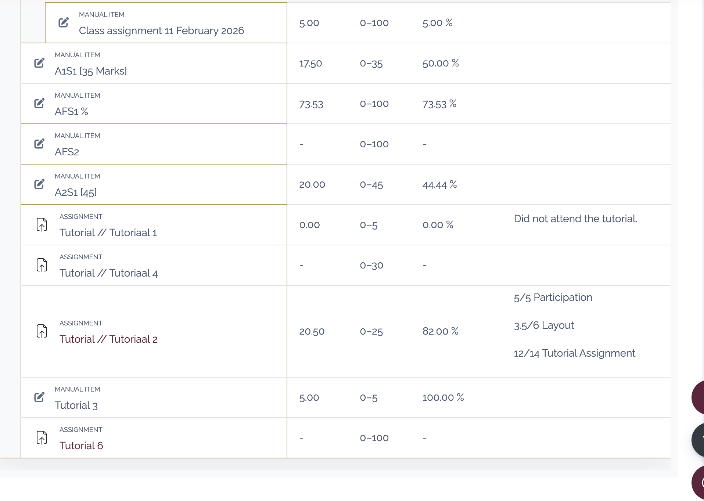

2026-14337-144 Law Of Persons / Personereg - 144 - NO MARKS YET
2026-51527-114 Legal Skills / Regsvaardighede - 114 -THIS MODULE HAS ENDED
2026-14336-178 Intro to Constitutional Law and Statutory Interpretation / Inleiding tot Staatsreg en Uitleg van Wetstekste -
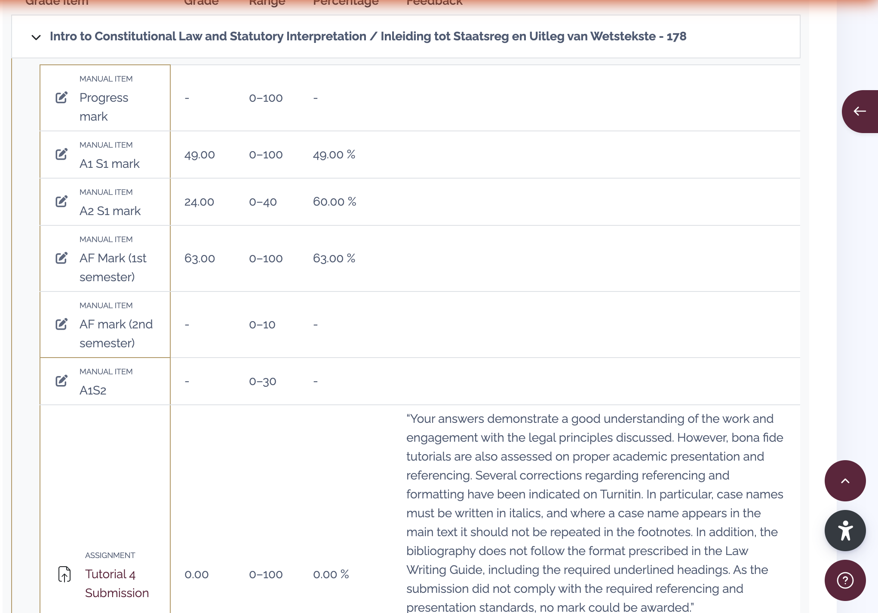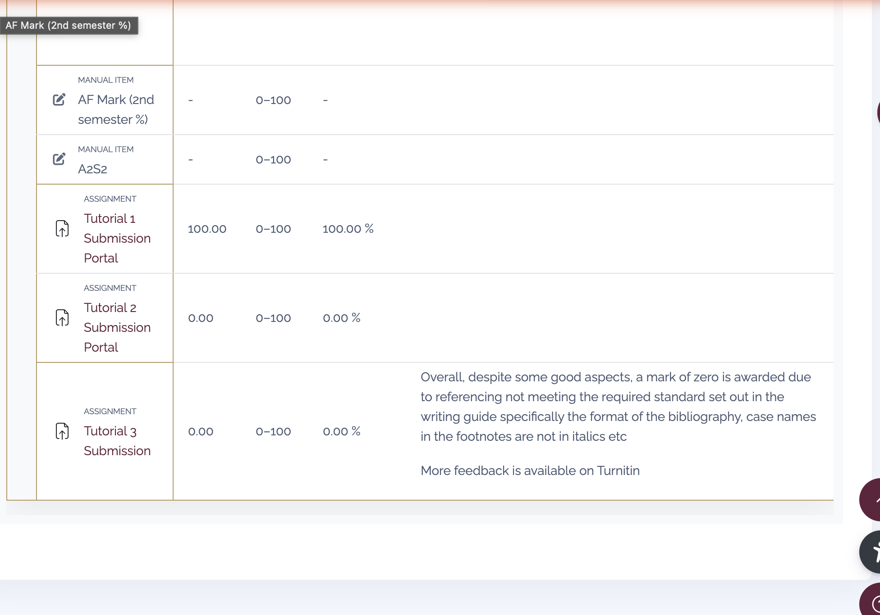

Tab 3
All important dates are in the calendar semester 2 zip which we made a while ago

